**DAILY ONLINE ACTIVITIES SUMMARY**

|  |  |  |  |  |  |  |  |  |
| --- | --- | --- | --- | --- | --- | --- | --- | --- |
| **Date:** | **18-05-2020** | | | | | **Name:** | **Raksha S** | |
| **Sem & Sec** | **6th B** | | | | | **USN:** | **4AL17CS073** | |
| **Online Test Summary** | | | | | | | | |
| **Subject** | | **Cryptography Network Security & Cyber Laws (CNSC)** | | | | | | |
| **Max. Marks** | | **60** | | **Score** | | | **43** | |
| **Certification Course Summary** | | | | | | | | |
| **Course** | **FullStack Webdevelopment** | | | | | | | |
| **Certificate Provider** | | | **Greatlearning** | | **Duration** | | | **45 days** |
| **Coding Challenges** | | | | | | | | |
| 1. Problem Statement: 1. Using methods charAt() & length() of String class, write a program to print the frequency of each character in a string.“Hello friend”.Output should be.-: 1,d: 1,e: **2,**f: 1, (continued for all character in the string) 2. 2. Write down a java program to print even and odd numbers series respectively from two threads: t1 and t2 synchronizing on a shared objectLet t1 print message “ping — >” and t2 print message “,—-pong”.Take as command line arguments, the following inputs to the program: Sleep Interval for thread t1 Write down a java program to print even and odd numbers series respectively from two threads: t1 and t2 synchronizing on a shared object | | | | | | | | |
| **Status:** YES, Completed all Programs | | | | | | | | |
| **Uploaded the report in Github** | | | | | **YES** | | | |
| **If yes Repository name** | | | | | <https://github.com/raksha05/Daily-Status>/Raksha 4AL17CS073/Raksha | | | |
| **Uploaded the report in slack** | | | | | **YES** | | | |

Online Test Details: (Attach the snapshot and briefly write the report for the same) 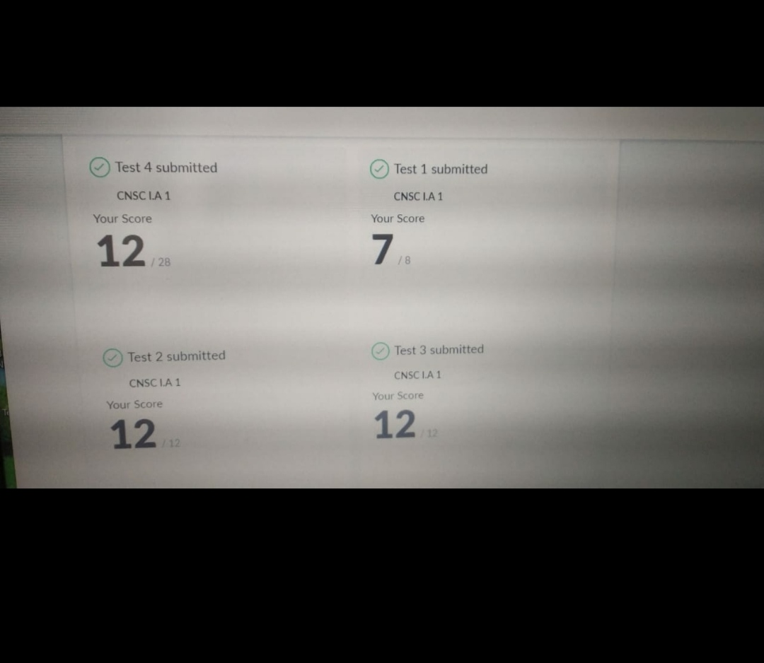

Scored 43 out of 60 in CGV 1st I.A test

Certification Course Details: (Attach the snapshot and briefly write the report for the same) 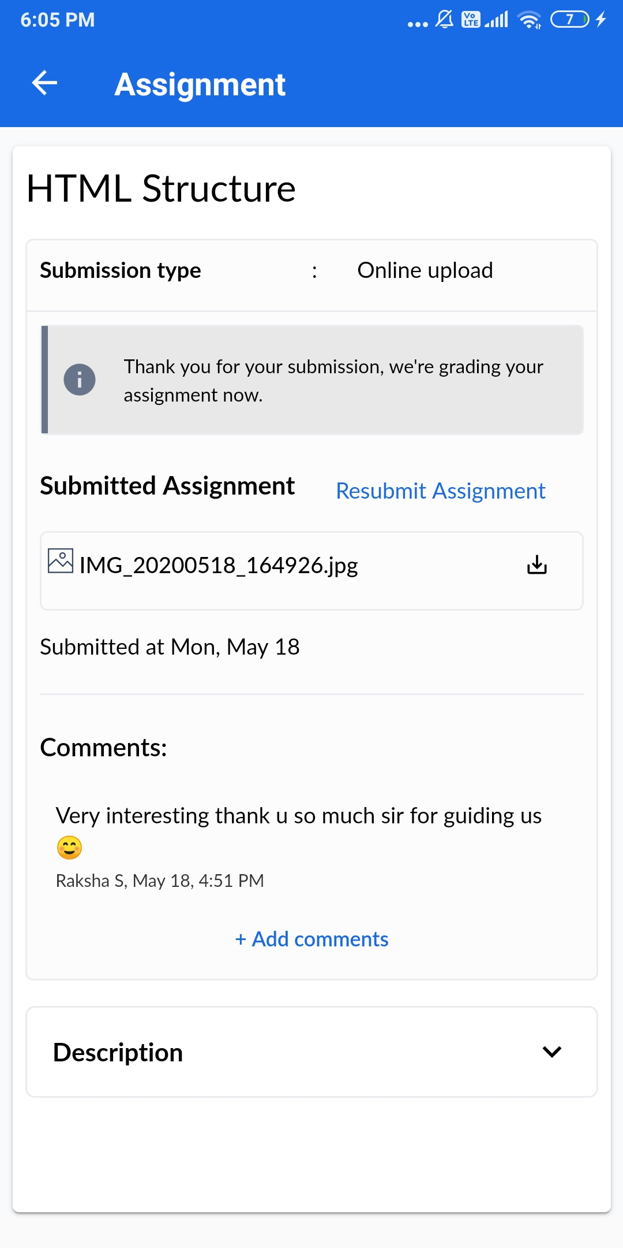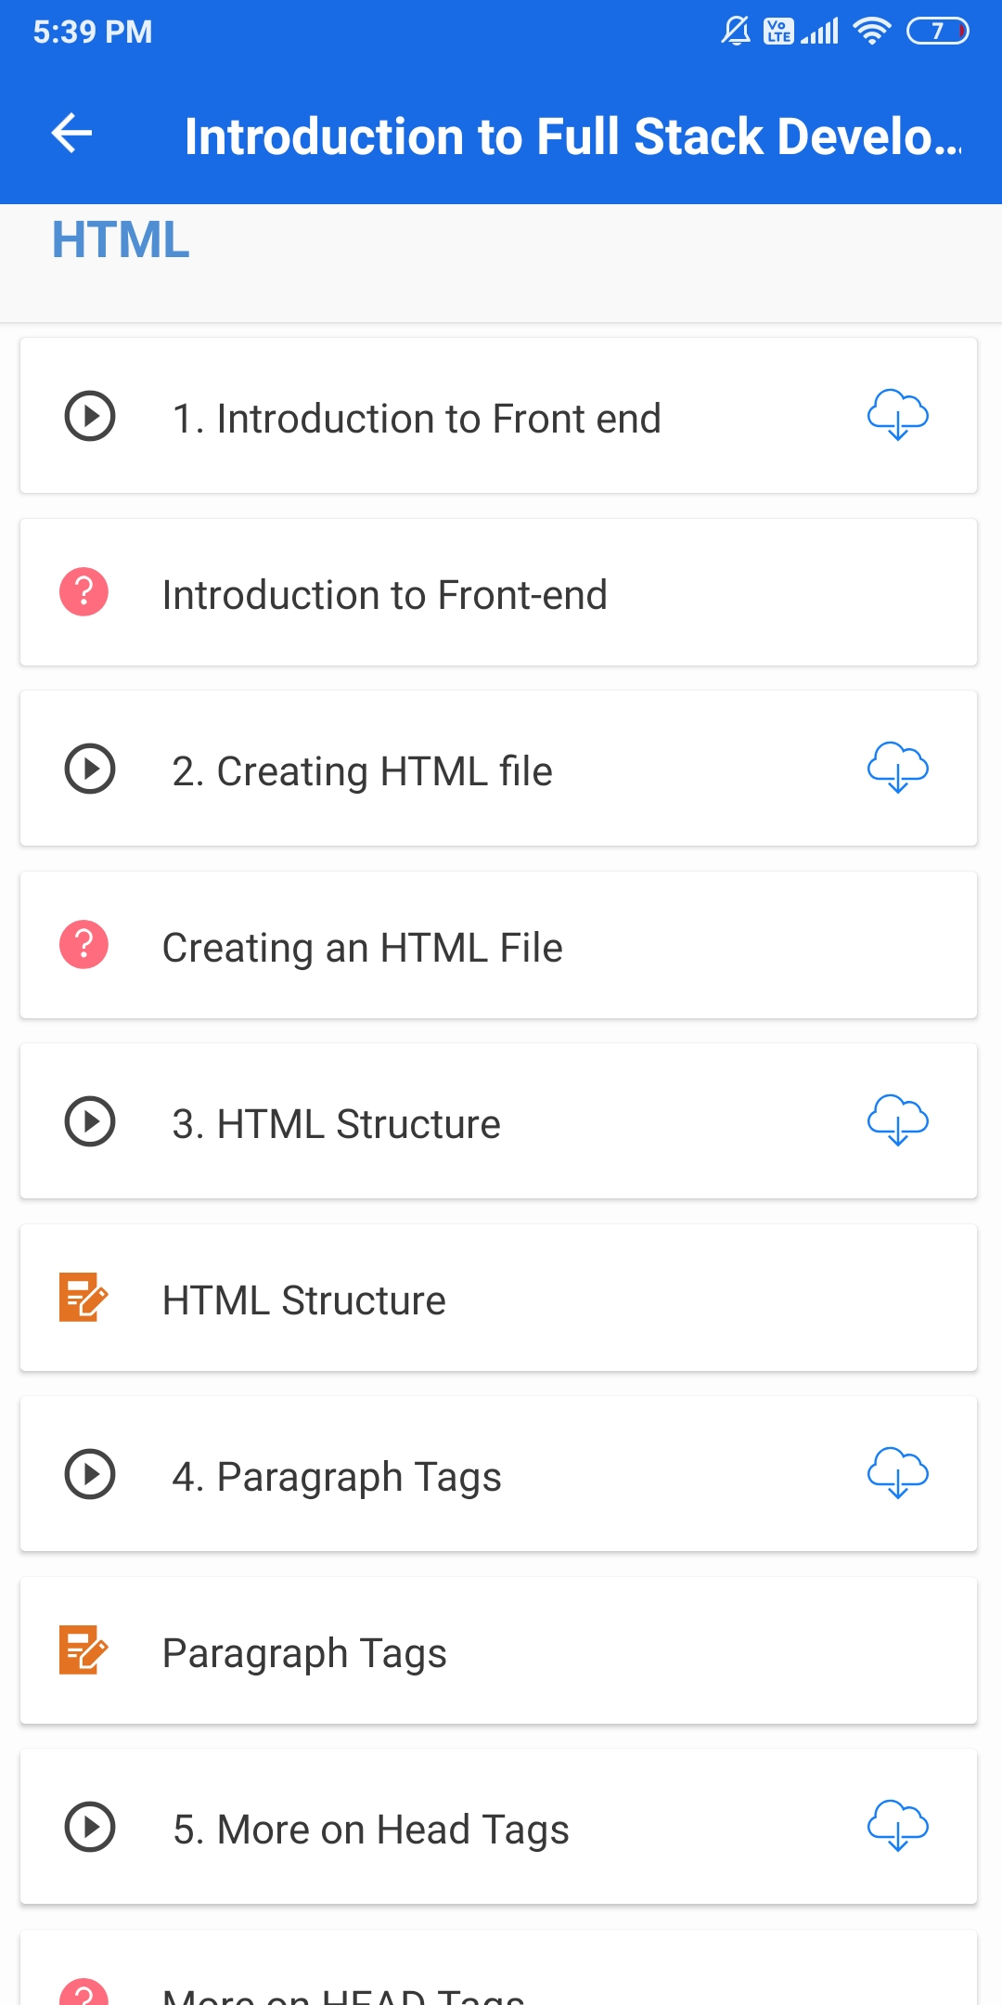

The above course is being taken up by me is based on FullStack. It started with the html commands, today in online course I studied about the overview of front end and the first in that learnt basics in webdevelopment and submitted the assignment

Coding Challenges Details: (Attach the snapshot and briefly write the report for the same)

Program1: Program 1

import java.util.Scanner;

public class Main

{

public static void main(String args[])

{

int i;

String str;

int counter[] = new int[256];

Scanner in = new Scanner(System.in);

System.out.print("Enter a String : ");

str=in.nextLine();

for (i = 0; i < str.length(); i++) {

counter[(int) str.charAt(i)]++;

}

for (i = 0; i < 256; i++) {

if (counter[i] != 0) {

System.out.println( (char) i + ":" +counter[i]);

}

}

}

}

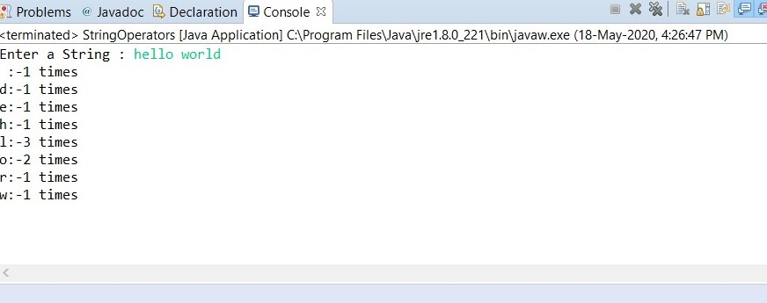

Program2:

class OddThread extends Thread

{

int limit;

sharedPrinter printer;

public OddThread(int limit, sharedPrinter printer)

{

this.limit = limit;

this.printer = printer;

}

@Override

public void run()

{

int oddNumber = 1;

while (oddNumber <= limit)

{

printer.printOdd(oddNumber);

oddNumber = oddNumber + 2;

}

}

}

class EvenThread extends Thread

{

int limit;

sharedPrinter printer;

public EvenThread(int limit, sharedPrinter printer)

{

this.limit = limit;

this.printer = printer;

